 C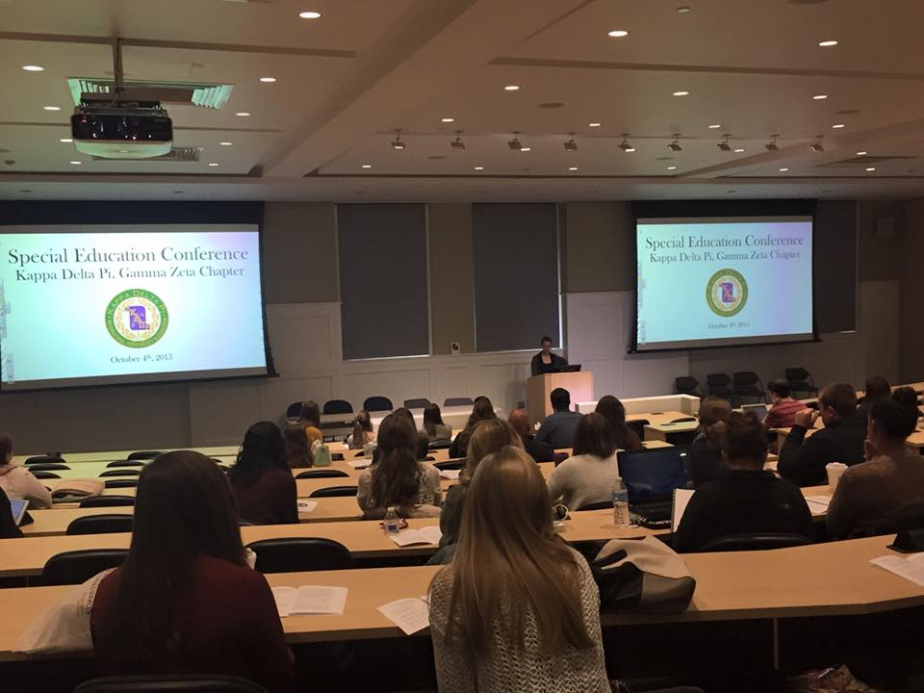 

**A Message from Your E-Board**

Hey KDP Members,

We hope everyone has been having a good semester so far! It’s pretty amazing how much we’ve accomplished so far this semester! At our September and October meetings we collected school supplies and books for Children’s Home Society. We also hosted a successful conference centered around the field of Special Education!

Your KDP Executive Board,

Jenna, Chelsea, Julia, Kat, Ashley, and Kayleigh

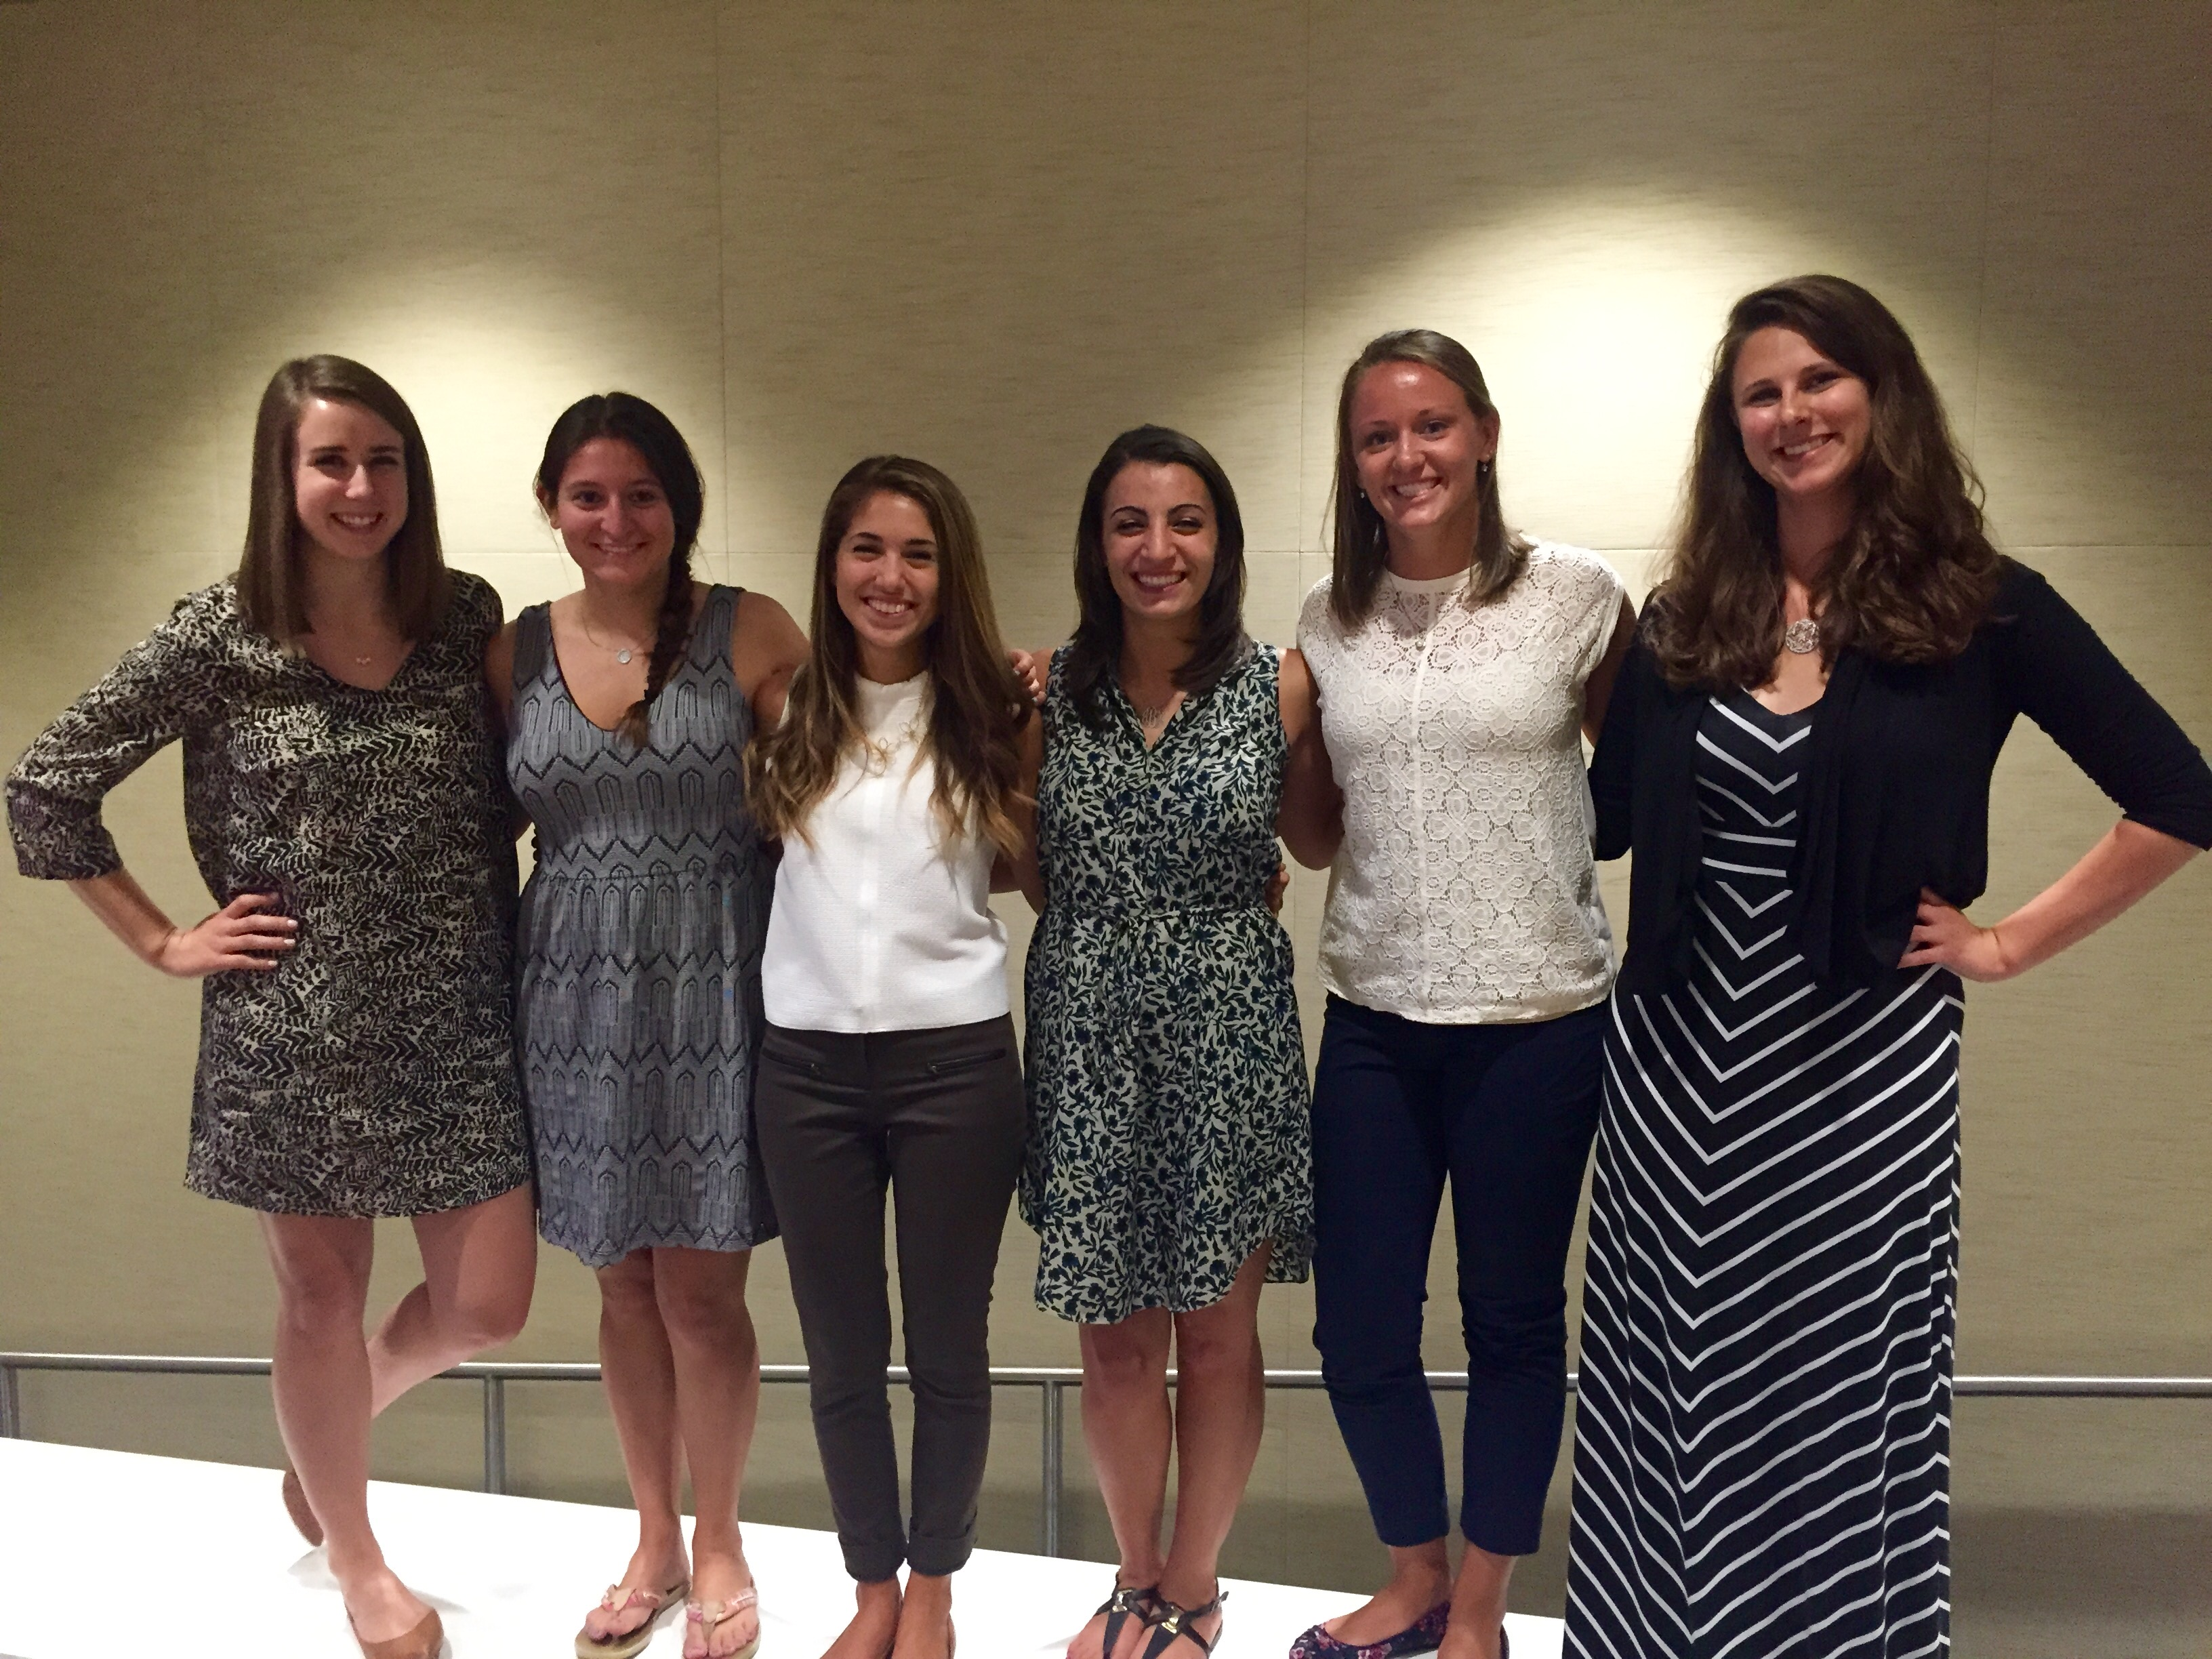

September/October 2015

KDP Newsflash

Keep earning your points!

Points: You must earn 25 points to receive your honor cord if you are a sophomore inducted during the spring or 12 points if you are a junior inducted during the spring.

There will be one Google Doc per semester that asks you to identify activities in which you participated. The link is attached to the bottom of every email we send.

You can earn:

*1 point for every hour you volunteer with KDP

*1 point for every $50 you raise for any of our fundraisers or charity events

*1 point for bringing items to donate to the different drives held at each meeting

*1 point for each fundraiser in which you participate

*3 points for serving on a committee

*5 points for chairing a committee

*3 points for global student teaching half a semester

*5 points for studying abroad full semester

See an e-board member if you have any questions!

Gamma Zeta Chapter

Nicole DiMarco is a Senior Special Education and Mathematics major. Nicole has had much involvement in KDP during her time as a member. She has worked on our Literacy Alive committee where she designed and ran a literacy booth for the literacy carnival. She now serves as the Chair of the Fundraising Committee, setting up fundraiser opportunities for the chapter. Over the summer, Nicole worked at an Extended School Year program in the Manchester School District, where she also substitute teaches over breaks. Nicole loves being able to meet students that are studying different branches of education. She also enjoys connecting with individuals in the field of Education. Nicole is a valued member of our Chapter and we were so happy to be able to award her Member of the Month!

**Special Education Conference**

On Sunday, October 4, the Gamma Zeta Chapter of Kappa Delta Pi hosted its Special Education Conference. Students from majors across the School of Education at TCNJ, as well as Rider University, attended this conference to gain professional development experience for their future careers as educators. The day commenced with a presentation based around inclusion, from one of our own Executive Board members, Ashley Teets. The remainder of the conference consisted of three workshop sessions, during which attendees were able to choose presentations that interested them. Workshop presentations were given by professors, practicing teachers, and other education professionals, and covered topics including ADHD, Dyslexia, Special Education terminology, Differentiation, Secondary Special Education, and ESL. One of the most popular sessions was the Special Education panel, which was hosted by four panelists from the background of Special Education. They responded to questions about the field and offered as much guidance as possible in response to the challenging parts of teaching Special Education and the stigmas associated with it. The Kappa Delta Pi executive board would like to thank their advisor Dr. Anthony Conte, Dean Passe, Assistant Dean Fleming, the speakers, and the students who attended for their part in this successful day.

KDP Newsflash

Member of the Month!

September/October 2015

**Monthly Meeting Incentive:**

Coming to monthly meetings is not only a great way to learn, socialize, and earn points toward your honor cord…it can also be a way to receive a prize! Each time you come to a meeting you have the opportunity to receive a gift card!

Tickets will be given out at the beginning of each meeting and a winner will be drawn at the end. This incentive program is designed to encourage regular attendance at our monthly meetings and raise the number of active members in the chapter.

KDP Newsflash

**Upcoming Events!**

**Get excited about these events happening this semester!**

|  |  |
| --- | --- |
| **ETS Praxis Review Webinar** | **November 4 (8-8:30)** |
| **November General Body Meeting** | **November 4 (8:30)** |
| **Praxis Review Workshop** | **November 17 (5:00 – 8:00P.M.)** |
| **Fall Induction** | **November 21** |
| **Education Bazaar** | **December 1 & 3** |

September/October 2015

Fall Induction

The fall induction for new members will be held on Saturday, November 21 at 10:00 am in the Education Building, Room 115.

**So to TEACH  
that our words inspire a will to learn**

**So to SERVE  
that each day may enhance the growth of exploring minds**

**So to LIVE  
that we may guide young and old to know the truth and love the right.**

Kappa Delta Pi Executive Board

Jenna Bruni and Chelsea Altchek - Co-Presidents

Julia Albretsen - Vice President  
Kathryn Gallo - Secretary  
Ashley Teets - Treasurer  
Kayleigh Russell - Historian

Dr. Anthony E. Conte - Faculty Counselor

[kdphonor@tcnj.edu](mailto:kdphonor@tcnj.edu)