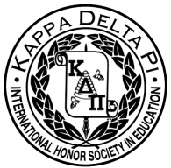
Agenda: October 7, 2015
8:30PM Ed Building 115

- Welcome Back!
*Monthly Collection – Book Drive
*Monthly Raffle
* Member of the Month
- Apply!! Due the first of the month

* Thank you to everyone who attended the conference!
- Certificate sent to everyone who attended 3 hours or more
- After meeting, survey will be sent out regarding thoughts/improvements

II. Points
* Google doc is updated with recent events, make sure to record points
  - https://docs.google.com/spreadsheets/d/19DEZD7EqFev3aWMxae-gtX1DWzkQt-tpEMwe8b-lvac/edit#gid=0

- Upcoming Events

* Peer Mentoring Program
- Need: Sophomores and Juniors
  - Help freshmen education majors choose classes/be a resource for them to use
- 1 point for applying
- 5 points for being a mentor

*Praxis ETS Webinar
- November 4th, 8:00-8:30 PM before the General Body Meeting

* Fall Induction
- Saturday, November 21st
- If you didn’t go to spring induction, you must attend

* Presentations
- Daniel Hardaker- “Whole-Brain Teaching Techniques”

IV Committee Chair Announcements
* Fundraising—Nicole DiMarco
- Sweatshirts ($28)

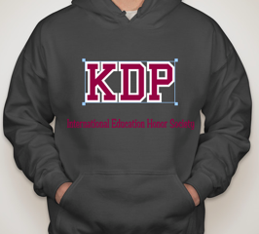
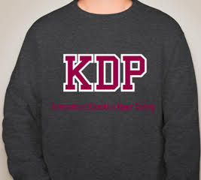

- Mamma Flora’s Fundraiser- TODAY
  - Buy food!!!

V. Stay Tuned
* Next meeting November 4th – 8:30 PM
* Check out our new bulletin board (Shout out to Kayleigh and Kat!) for information on upcoming events and meeting minutes!
*Facebook: Like us! “TCNJ KDP Honor Society”
*Website:www.kdpgammazeta.weebly.com

