 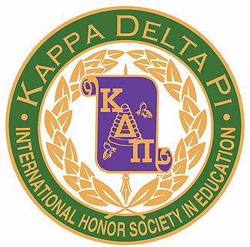 

Congratulations Jillian!

**A Message from Your E-Board**

Hello KDP Members!

Happy December! We can’t believe how quickly the year is going by! We’ve accomplished so much as an honor society this semester, and we would like to take a moment to thank each and every one of our members for their continued involvement. Your donations to supply drives, attendance at meetings, and participation in society events does not go unnoticed, and we truly appreciate all of the time that you put in. We would not be one of the most successful chapters in the nation without our outstanding members!

Best of luck during finals week,

Your KDP Executive Board,

Lana, Kevin, Sarah, Rebecca, Lori and Erica

**November Member of the Month:**

***Jillian Raleigh***

Lana, Jillian is a senior Elementary Education and English major, and we are so excited to have her as our member of the month! Over the summer, she volunteered at an oncology camp through the YMCA, and she is student teaching this semester in a second grade classroom. Jillian is a valued member of KDP and has taken every opportunity to participate in our chapter. Way to go Jillian!



November/ December 2014

Vol. 5 Issue 2

KDP Newsflash

Keep earning your points!

Points: You must earn 25 points to receive your honor cord if you are a sophomore inducted during the spring or 12 points if you are a junior inducted during the spring.

There will be one Google Doc per semester that asks you to identify activities in which you participated. The link is attached to the bottom of every email we send.

You can earn:

*1 point for every hour you volunteer with KDP

*1 point for every $50 you raise for any of our fundraisers or charity events

*1 point for bringing items to donate to the different drives held at each meeting

*1 point for each fundraiser in which you participate

*3 points for serving on a committee

*5 points for chairing a committee

*3 points for global student teaching half a semester

*5 points for studying abroad full semester

See an e-board member if you have any questions!

Gamma Zeta Chapter

**Literacy Across the Curriculum Conference**

On Saturday, November 8, the Kappa Delta Pi Education Honor Society held their first annual Literacy Across the Curriculum Conference. They are proud to announce it as a huge success! Sixty-eight students from majors across the School of Education attended the four-hour conference to learn how to integrate literacy into all subjects in their future classrooms. The morning commenced with a presentation by the keynote speaker: award-winning children’s author Lisa Funari-Willever. Following this presentation, attendees were able to choose workshops to attend during three different sessions. Presenters at these workshops included Education and Literature professors, as well as Lynne Azarchi and Rebecca Erickson from Kidsbridge Tolerance Museum. All attendees left with a toolkit of new techniques and ideas that they can implement in their future classrooms. The Kappa Delta Pi Executive Board and faculty advisor, Dr. Conte, would like to thank both presenters and attendees for making this day a huge success, as well as Dean Passe and Assistant Dean Fleming for their continued support of the Gamma Zeta chapter. We hope to continue this conference annually for future pre-service TCNJ educators.

Photo Gallery

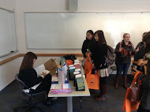

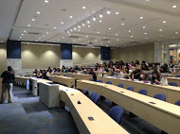

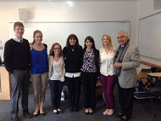

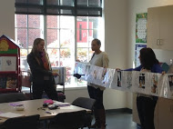

November/ December 2014

Vol. 5 Issue 2

KDP Newsflash

**So to TEACH  
that our words inspire a will to learn**

**So to SERVE  
that each day may enhance the growth of exploring minds**

**So to LIVE  
that we may guide young and old to know the truth and love the right.**

**Monthly Meeting Incentive:**

Coming to monthly meetings is not only a great way to learn, socialize, and earn points toward your honor cord…it can also be a way to receive a prize! Each time you come to a meeting you have the opportunity to receive a gift card!

Tickets will be given out at the beginning of each meeting and a winner will be drawn at the end. This incentive program is designed to encourage regular attendance at our monthly meetings and raise the number of active members in the chapter.

**December Cookie Social:**

**This month, for our general body meeting, we had a cookie decorating social. Our members did an excellent job donating cookies, icing, and sprinkles. The event was a great way to end the semester and give our members a chance to socialize. After this successful event, we plan to have more socials in the future!**

Kappa Delta Pi Executive Board

Lana Rahal and Kevin Mount - Co-Presidents

Sarah Westfall - Vice President  
Rebecca Havens - Secretary  
Lori Genovesi - Treasurer  
Erica Joel - Historian

Dr. Anthony E. Conte - Faculty Counselor

kdphonor@tcnj.edu

KDP Newsflash

**Upcoming Events!**

**Get excited about these events happening next semester!**

|  |  |
| --- | --- |
| **February 4** | **General Body Meeting** |
| **March 4** | **General Body Meeting** |
| **March 8** | **Conference for Aspiring Teachers** |
| **April 1** | **General Body Meeting** |
| **April 29** | **General Body Meeting** |
| **May 9** | **Spring Induction Ceremony** |

November/ December 2014

Vol. 5 Issue 2