 C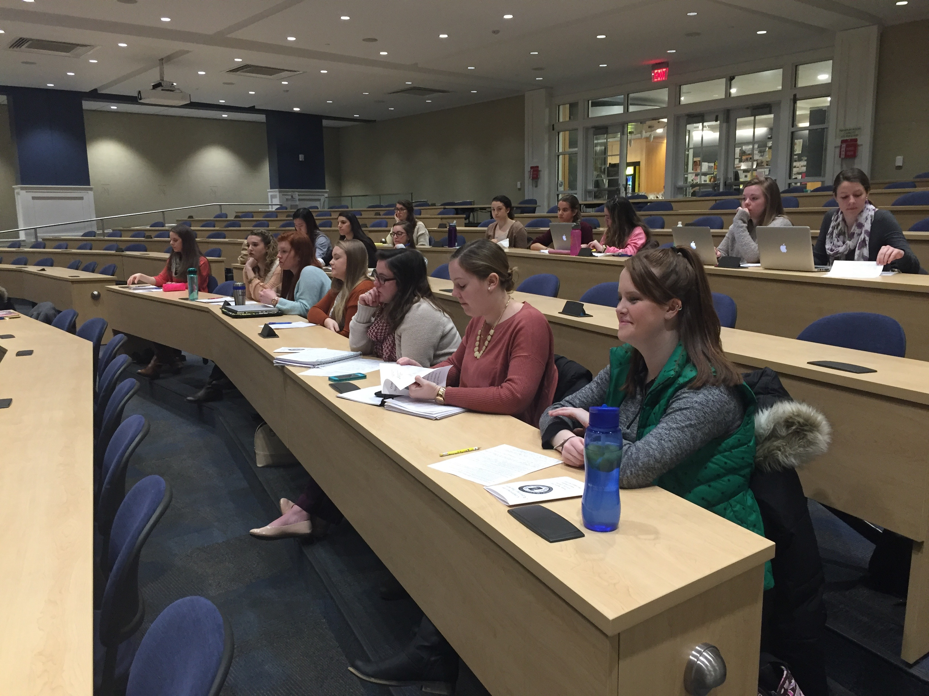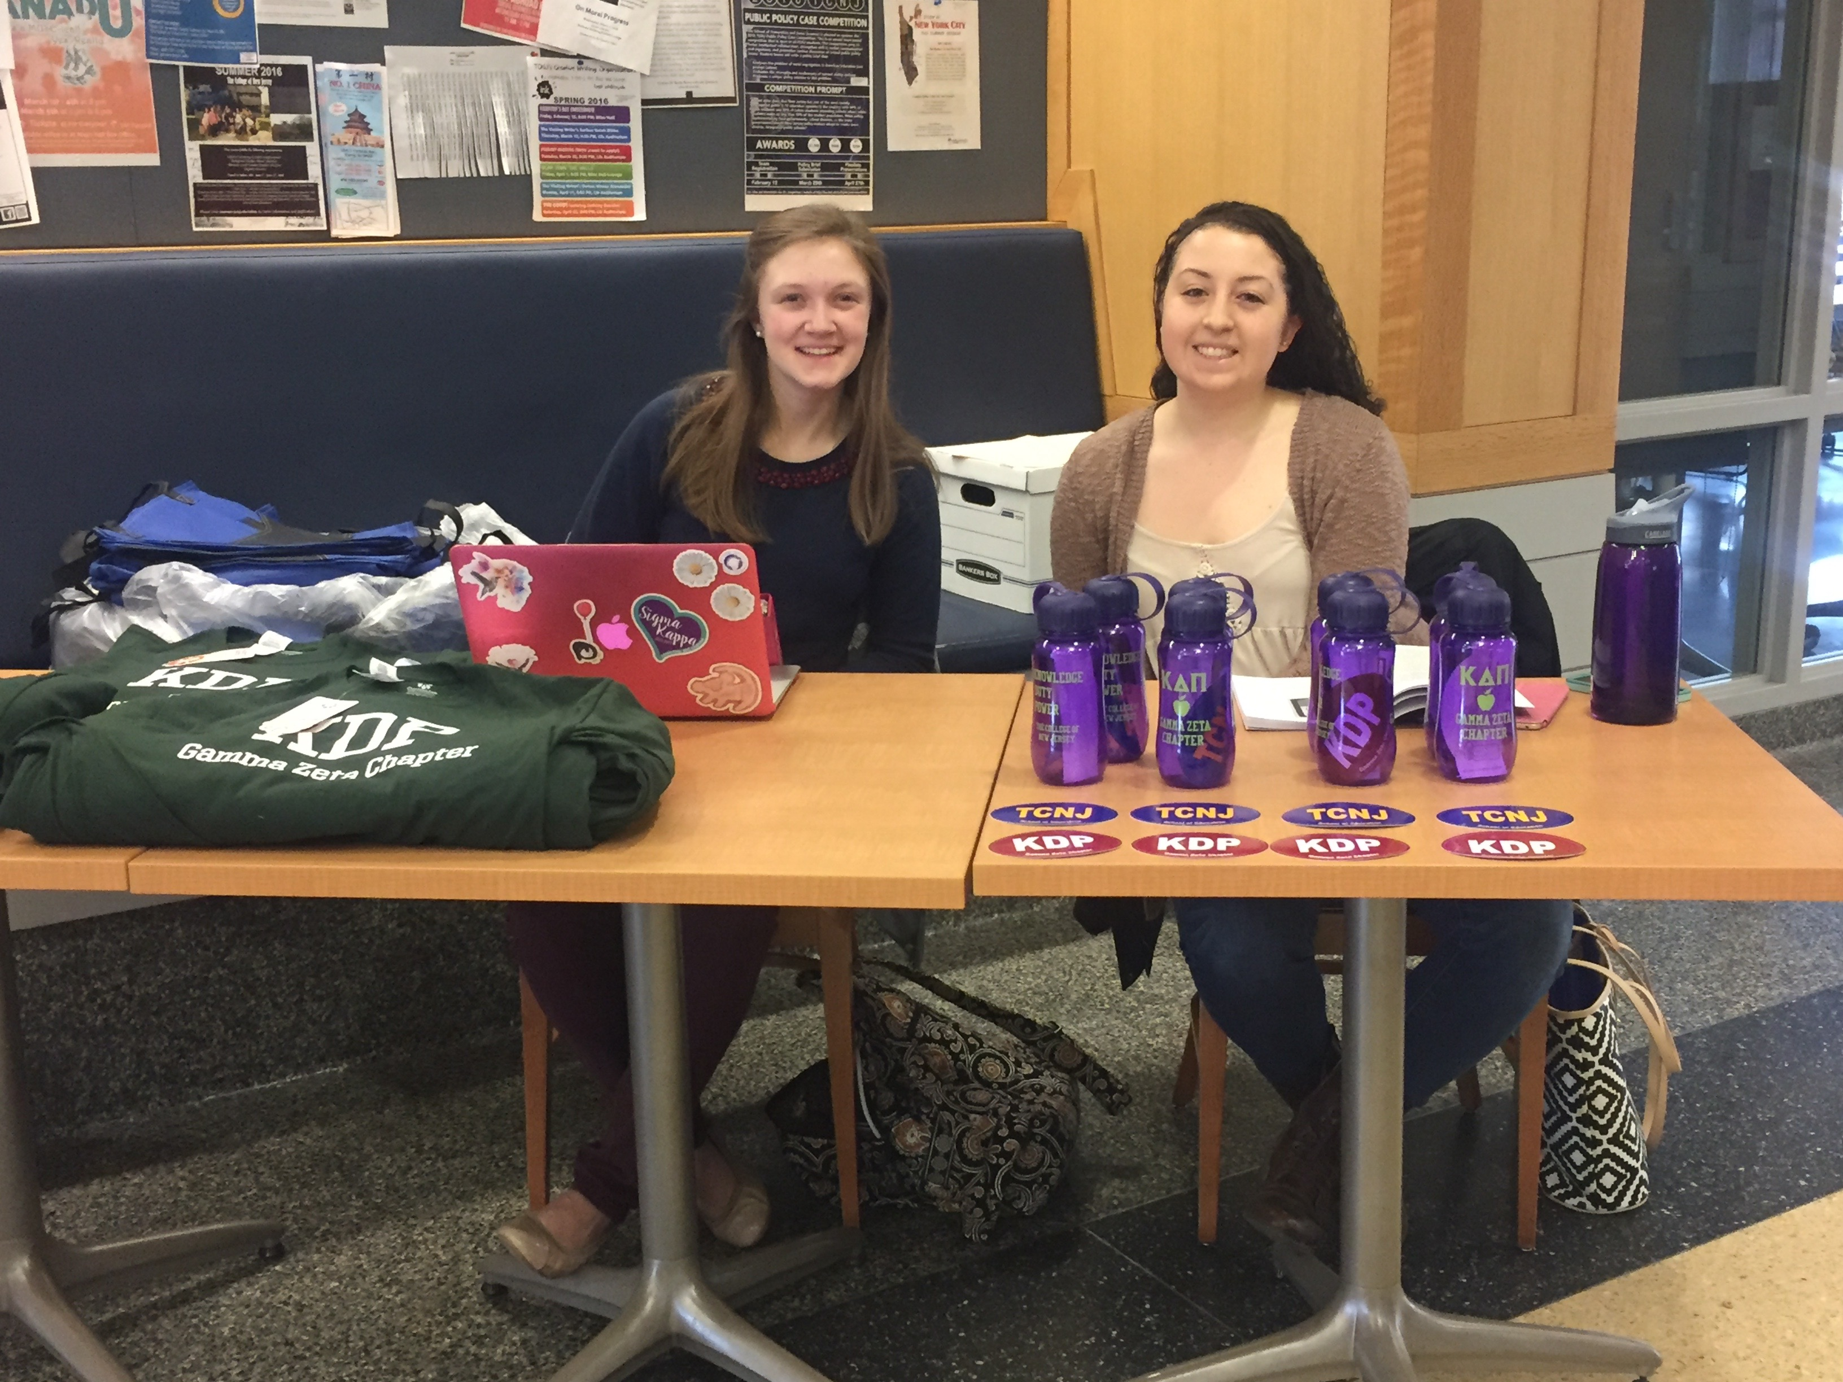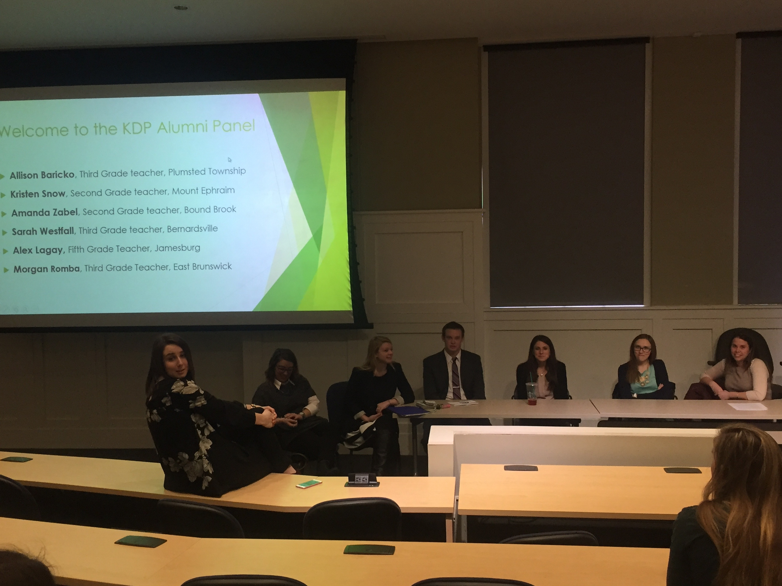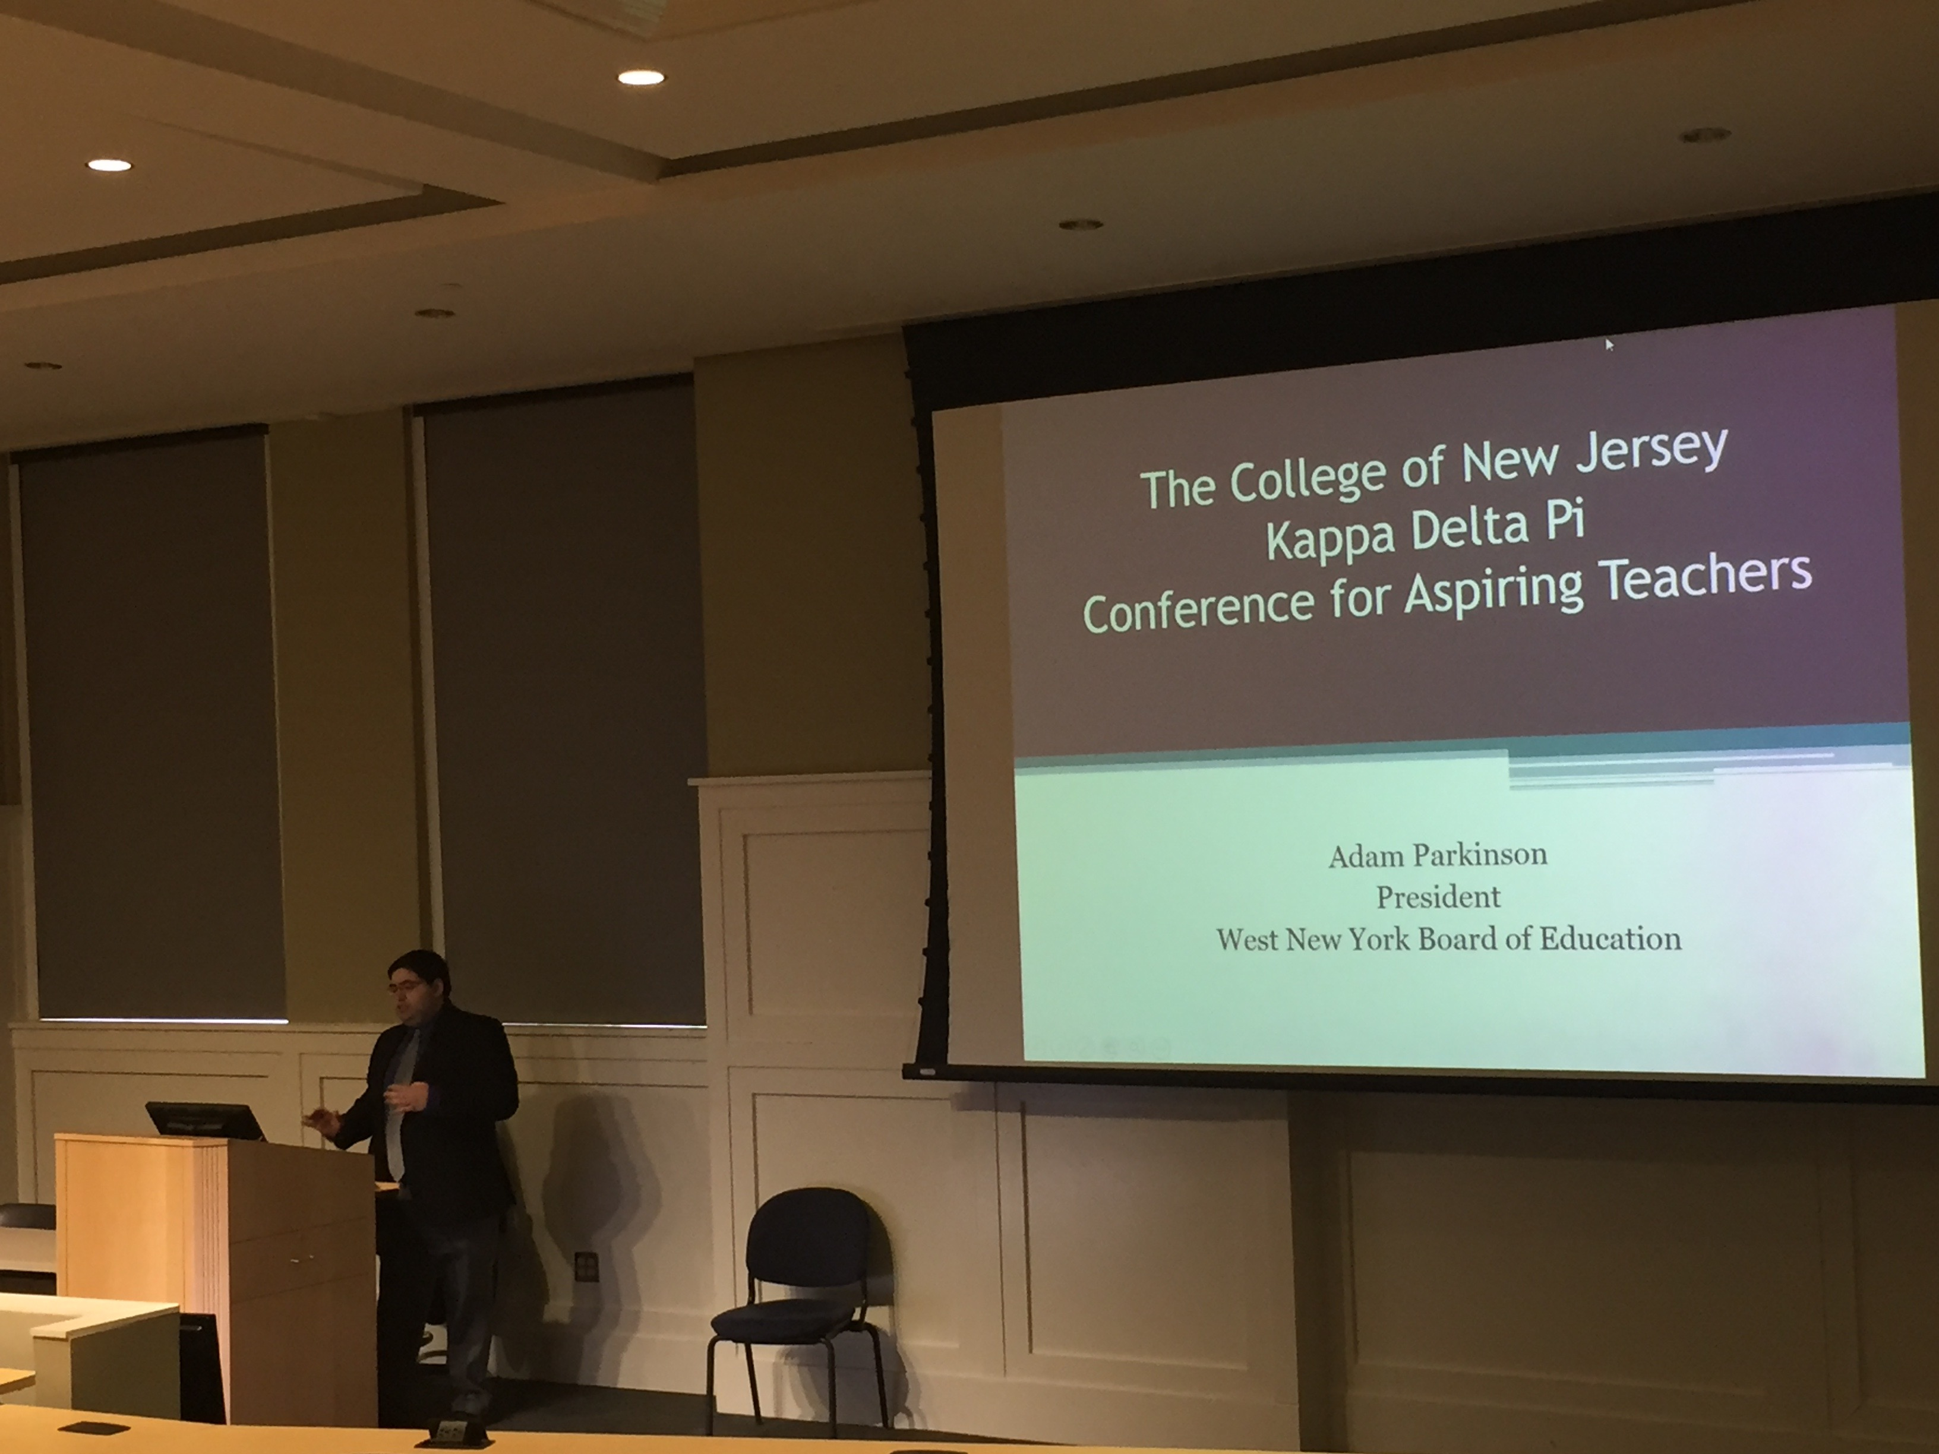 

**`A Message from Your E-Board**

Hello KDP Members,

We hope everyone has been having a good semester so far! It’s pretty amazing how much we’ve accomplished so far this semester! At our February meeting we collected school supplies for the Children’s Home Society. At our March meeting we collected Easter Baskets to donate to underprivileged children and their families in Trenton. We also hosted our annual conference for Aspiring Teacher.

Your KDP Executive Board,

Jenna, Chelsea, Julia, Kat, Ashley, and Kayleigh

**March Member of the Month**

***Marissa Hazel***

Marissa is a senior Health and Exercise-Teaching (K-12) major and we are so excited to have her as our member of the month! Over the summer, she worked as a Summer Recreation Supervisor for second and fourth graders. In addition to this, she is a student representative of the Health and Physical Education Teachers state organization. Marissa has had many successful practicum experiences and continues to be a valued member of Kappa Delta Pi, participating in many drives and donation! Congrats, Marissa!



March 2016

KDP Newsflash

Keep earning your points!

Points: You must earn 25 points to receive your honor cord if you are a sophomore inducted during the spring or 12 points if you are a junior inducted during the spring.

There will be one Google Doc per semester that asks you to identify activities in which you participated. The link is attached to the bottom of every email we send.

You can earn:

*1 point for every hour you volunteer with KDP

*1 point for every $50 you raise for any of our fundraisers or charity events

*1 point for bringing items to donate to the different drives held at each meeting

*1 point for each fundraiser in which you participate

*3 points for serving on a committee

*5 points for chairing a committee

*3 points for global student teaching half a semester

*5 points for studying abroad full semester

See an e-board member if you have any questions!

Gamma Zeta Chapter

**Conference for Aspiring Teachers**

On Sunday, March 6th, the Gamma Zeta Chapter of Kappa Delta Pi hosted its Annual Conference for Aspiring Teachers. Students from majors across the School of Education at TCNJ attended this conference to gain professional development experience for their future careers as educators. The day commenced with our Keynote speaker Adam Parkinson, one of the youngest men in New Jersey history to serve on a Board of Education. The remainder of the conference consisted of three workshop sessions, with different presentations that attendees were able to choose. Professors, practicing teachers, KDP alumni, and other educational professionals gave the presentations. The presentations covered topics including a Principal Panel, 1st Year Teacher Panel, STEM, Urban Education, Secondary Education, Deaf Education, Pre-K, Student Teaching 101, and Behavioral Management. One of our most popular sessions was our Principal session, held by Larry Fieber, the New Jersey Future Educators Association State Director. During this session, one of our own KDP students was chosen to participate in a mock interview with Mr. Fieber. Attendees were able to listen to questions that might be asked during a job interview and they were able to learn appropriate ways in which they should respond to specific questions. The Kappa Delta Pi executive board would like to thank Dean Passe, Assistant Dean Fleming, their faculty counselor Dr. Anthony E. Conte, the presenters, and the students who attended for their part in this successful day.

Photo Gallery

KDP Newsflash

March 2016

**Monthly Meeting Incentive:**

Coming to monthly meetings is not only a great way to learn, socialize, and earn points toward your honor cord…it can also be a way to receive a prize! Each time you come to a meeting you have the opportunity to receive a gift card! Tickets will be given out at the beginning of each meeting and a winner will be drawn at the end. This incentive program is designed to encourage regular attendance at our monthly meetings and raise the number of active members in the chapter.

KDP Newsflash

**Upcoming Events!**

**Get excited about these events happening this semester!**

|  |  |
| --- | --- |
| **School of Education Conference** | **Wednesday, March 30th, 12-3 PM** |
| **General Body Meeting/Eboard Elections** | **Wednesday, April 6, at 8:30PM** |
| **Rebecca Kamen talk on Art, Science, and Dyslexia** | **March 23, 1:00PM, Mayo Hall** |
| **TCNJ Alumni Party** | **April 30, 4:30-6:30PM** |

March 2016

Kappa Delta Pi Executive Board

Jenna Bruni and Chelsea Altchek - Co-Presidents

Julia Albretsen - Vice President  
Kathryn Gallo - Secretary  
Ashley Teets - Treasurer  
Kayleigh Russell - Historian

Dr. Anthony E. Conte - Faculty Counselor

kdphonor@tcnj.edu

**So to TEACH  
that our words inspire a will to learn**

**So to SERVE  
that each day may enhance the growth of exploring minds**

**So to LIVE  
that we may guide young and old to know the truth and love the right.**

**Gamma Zeta Chapter Profile**

* **Fall 2015 Induction: 88 members inducted**
* **Spring 2016 Induction: 80 members anticipated**
* **2016 Honor Cord Recipients: 50 members anticipated**