 C

Keep earning your points!

Points: The number of points that you need to earn in order to be eligible to receive an honor cord depends on when you were inducted.

*Fall or spring of sophomore year: 25 points

*Fall of junior year: 20 points

*Spring of junior year or fall of senior year: 12 points

There will be one Google Doc per year that asks you to identify activities in which you participated. The link is attached to the bottom of every email we send.

How to Earn Points

*1 point for every hour you volunteer with KDP

*1 point for every $50 you raise for any of our fundraisers or charity events

*1 point for bringing items to donate to the different drives held at each meeting

*1 point for each fundraiser in which you participate

*3 points for serving on a committee

*3 points for global student teaching for half of a semester

*5 points for studying abroad for a full semester

See an E-Board member if you have any questions!

**A Message from Your E-Board**

Hello KDP Members,

We hope everyone is having a great semester! We have had a tremendously successful year so far! At each meeting, we hold a donation drive for Children’s Home Society (CHS) in Trenton. In September, we collected school supplies and in October, we collected baby and Halloween items. On 10/1, we hosted our fall conference, “Classroom Management: New Perspectives” at which teachers from pre-school to high school shared their classroom management perspectives, opinions, and advice. On 10/15, we were thrilled to induct 65 new members into the Gamma Zeta chapter! Because KDP members enjoy working with children so much, we have been volunteering at Antheil Elementary School in Ewing. Volunteers helped out school staff at both their Scholastic Book Fair and Halloween Spooktacular this past month and look forward to volunteering at the school’s future events as well! As the year progresses, KDP members continue to work hard and pursue their passion for teaching.

Best,

Your KDP Executive Board:

Joe, Kayleigh, Kelsey, Kate, Delaney, Cloe, and Kayla

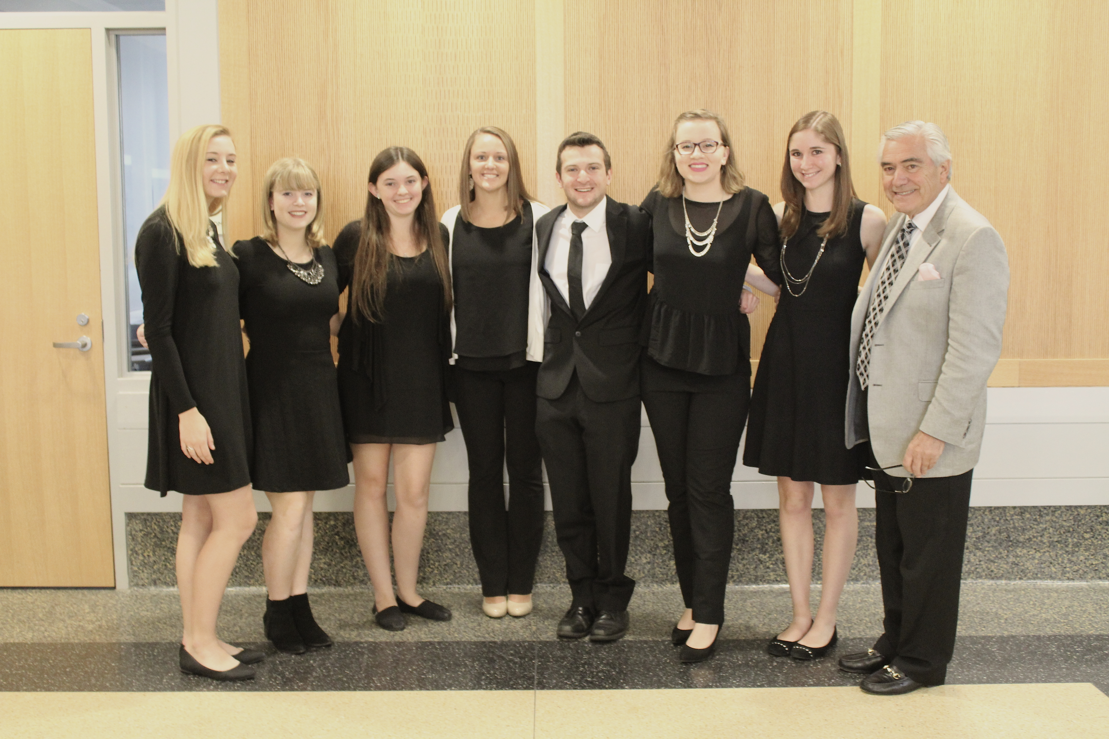

September/October 2016

KDP Newsflash

Gamma Zeta Chapter

wsflash

Gamma Zeta Chapter

**September**

Our Member of the Month in September was Tara Siesputowski, a senior deaf education and history major. Tara was inducted into KDP in spring 2015 and has been an active member ever since. A few of the KDP events that she has participated in over the years are the PRAXIS webinar, the Prison Pipeline workshop, and tabling at the Student Activities Fair.

Along with KDP, Tara is involved in Golden Key Honor Society. Through Golden Key, she advocates for the SPARK a Change initiative, which works to set at risk youth up for a successful future. In her Deaf Education practicum last semester, she conducted a Learning Fair on different safari-themed animals in American Sign Language (ASL). She is thankful to be a part of KDP because it has given her the opportunity to get to know other education majors, get experience and knowledge that she could not get in the classroom, and to participate in community service events and donation drives.

**October**

Our Member of the Month in October was Morgan Pestorius, a senior elementary education and iSTEM major with a minor in sustainability education. She was inducted in fall 2015 and, like Tara, has been an active member ever since. In spring 2015, she was on the conference committee, was a conference facilitator, and designed and ran the STEM station at Literacy Alive!

Over the summer, she was a nanny, a math tutor, and a private swim instructor. She is also a coach for Girls on the Run, a program that teaches 3rd-8th grade girls life skills through fun lessons and running games. She is currently student teaching in kindergarten, where she loves spending time in the school garden with her students. She values being a member of KDP because it introduced her to Girls on the Run, has allowed her to meet people with similar values and interests, and she has learned many skills at KDP conferences and events that she plans to implement in her own classroom.

Members of the Month

September/October 2016

**“Classroom Management: New Perspectives” Conference**

On Saturday, October 1st, the Gamma Zeta Chapter hosted its Fall Conference, “Classroom Management: New Perspectives.” Students from majors across the School of Education at TCNJ attended this conference to learn valuable classroom management skills and advice to implement in their practicum placements, student teaching, and future careers. Presentations were given by teachers who teach every age from preschool through high school.

The keynote speaker was Mrs. Karen Steliga, a veteran urban educator. She presented strategies that she uses daily to maintain a positive learning environment for her students.

For Session One, participants were able to choose between “A 21st Century Classroom: Flexible Seating and Student Choice”, “Teaching with Technology”, and “Responsive Classroom and Redirecting Behaviors.”

For Session Two, participants were able to choose between “Early Childhood Education: Classroom Management in Preschool”, “Elementary Education: Starting the Year off on the Right Foot”, and “Secondary Education: Managing Classrooms on the Middle and High School Level.”

The conference closed with a panel of teachers and a former principal, who responded to audience questions concerning classroom management. The Gamma Zeta Chapter executive board would like to thank our faculty advisor, Dr. Anthony E. Conte, our invited guests, our speakers, and the attendees for making the conference so successful.

KDP Newsflash

Gamma Zeta Chapter

KDP Newsflash

Gamma Zeta Chapter

**Monthly Meeting Incentive**

Coming to monthly meetings is not only a great way to learn, socialize, and earn points toward your honor cord…it can also be a way to receive a prize! Each time you come to a meeting, you have the opportunity to receive free apparel!

Tickets are given out at the beginning of each meeting and a winner is drawn at the end. This incentive program is designed to encourage regular attendance at our monthly meetings and raise the number of active members in the chapter.

September/October 2016

**Upcoming Events**

**Get excited about the following events happening this semester!**

|  |  |
| --- | --- |
| **Event** | **Date and Time** |
| Tutoring program | Various dates and times |
| December General Body Meeting | Wednesday, December 7th at 8:30 P.M. |
| Ewing Township Elementary Schools’ Kids Vote! Volunteering | Tuesday, November 8th from 11:00 A.M.-7:00 P.M. (2 hour shifts) |
| Networking Night | Thursday, November 17th from 7:00-8:00 P.M. |



**So to TEACH  
that our words inspire a will to learn**

**So to SERVE  
that each day may enhance the growth of exploring minds**

**So to LIVE  
that we may guide young and old to know the truth and love the right.**

Kappa Delta Pi Executive Board

Joe Daly and Kayleigh Russell - Co-Presidents

Kelsey Collins - Vice President  
Kate Wester - Secretary  
Delaney Slater - Treasurer  
Cloe Tardiff – Historian

Kayla Taylor- Director of Alumni Relations

Dr. Anthony E. Conte - Faculty Counselor

kdphonor@tcnj.edu

Fall Induction

Our fall induction for new members was held on Saturday, October 15th at 10:00 A.M. in Education Building Room 212. 65 new members were inducted into the Gamma Zeta Chapter.