

**Agenda: February 4th, 2014**

**8:30PM School of Education 115**

I. Welcome!

*Monthly Collection –Monetary Donation, $3 for 1 point or $5 for 2points

*Monthly Raffle- $15 Dunkin Donuts  
*Member of the Month- $25 Barnes and Noble

\***Executive Board Positions**

II. Points  
 * Points are required to earn Honor Cord at graduation, you cannot buy them  
 * 25 points for sophomores/ juniors, 12 points for seniors (by the end of your senior year)

* Points are logged individually on an honor system using Google Doc  
 [https://docs.google.com/a/apps.tcnj.edu/spreadsheets/d/120fZDmDKy5dQ2Gw3FeClk-vYzaqQ](https://docs.google.com/a/apps.tcnj.edu/spreadsheets/d/120fZDmDKy5dQ2Gw3FeClk-vYzaqQ-vcb5mnt0jk78kM/edit)  [vcb5mnt0jk78kM/HYPERLINK "https://docs.google.com/a/apps.tcnj.edu/spreadsheets/d/120fZDmDKy5dQ2Gw3FeClk-vYzaqQ-vcb5mnt0jk78kM/edit"edit#gidHYPERLINK "https://docs.google.com/a/apps.tcnj.edu/spreadsheets/d/120fZDmDKy5dQ2Gw3FeClk-vYzaqQ-vcb5mnt0jk78kM/edit"=0](https://docs.google.com/a/apps.tcnj.edu/spreadsheets/d/120fZDmDKy5dQ2Gw3FeClk-vYzaqQ-vcb5mnt0jk78kM/edit)  
 * Points are earned one point per hour of service unless otherwise specified and one point for   
 drive donations

III. Long Sleeve Shirt Sale  
 *$18, must be paid before you receive your shirt  
 *Order forms due by Friday, February 6th by noon, in the KDP mailbox on the 2nd floor of student center

IV. Upcoming Events

*Breathe in, Breathe out Challenge---month of February (see attached)

*Speaker Kerry Magro: Autism Awareness in Education-- Wednesday, February 18th, 12:30 in Ed 113

*Technology Cnference-- Saturday, February 21st; Tech Savvy Teachers 9am-12:30

*Nominations for new Executive Board--Wednesday, March 4th at meeting

*Conference for Aspiring Teachers--- Sunday, March 8th  
 *Spring Induction---Saturday, May 9th

VCommittee Chair Announcements

* Fundraising-- Ashley Teets  
 -Piccolos, Thursday, February 19th; flyer **must** be printed, all day event

*Literacy Alive!--Samantha Altman and Christine Seddon

VI. Stay Tuned

* Next Meeting: Wednesday, March 4th. We will be holding nominations for the 2015-2016 eboard!

*Facebook: Like us! “TCNJ KDP Honor Society”  
 *Website:[www.kdpgammazeta.weebly.com](http://www.kdpgammazeta.weebly.com/)

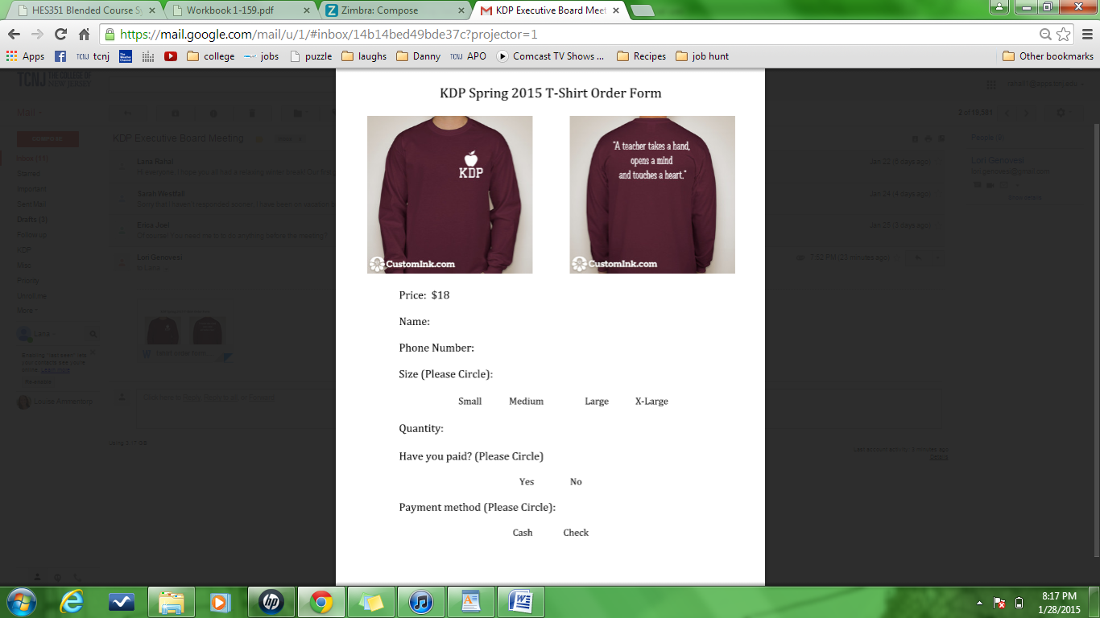

|  |  |  |  |  |  |  |  |  |  |
| --- | --- | --- | --- | --- | --- | --- | --- | --- | --- |
| |  |  | | --- | --- | | https://my.brockport.edu/images/W460xL600/0/noshadow/Event/de777f0b0927404b846e53004314d706.jpg  http://www.piccolotrattoria.com/wp-content/uploads/2013/09/logo1.png |  | | Go to Piccolo’s on Thursday, February 19th  for a KDP Fundraiser Bring this flyer and help support TCNJ’s Kappa Delta Pi! http://www.mbc.edu/kdp/images/New_KDP_logobit.pngThe national role of Kappa Delta Pi is to further the aims of education in research, collegiality and service, and to promote the highest academic ideals within the educational community. It is dedicated to its four cherished ideals: Humanity, Science, Service, and Toil. | |  | |  | |  | | --- | | Support TCNJ’s Education Honor Society!Bring this flyer to Piccolo’s10% of your order goes to KDPThursday, February 19thGo get the best pizza around! | |  | | Piccolo Trattoria Hopewell Crossing Shopping Center 800 R Denow Road Pennington, NJ 08534 609-737-9050 | |

