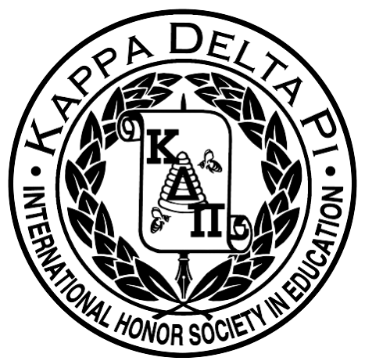

Agenda: March 19, 2014 General Body Meeting
8:30PM School of Education 115

- Welcome!
*Monthly Collection – Easter Baskets
*Monthly Raffle – Panera Gift card
*Next Meeting – April 16 th at 8:30 in ED 115

- Literacy Alive
*Friday, March 28th at 3:15 to 4:30pm
*Sign-up at the end of the meeting

- Piccolo’s Fundraiser – March 26th
*Flyer will be sent out later in the week with all the details!

- Relay for Life
*April 4-5 in the Recreation Center
*Join the School of Education Team
*1 point per hour if you are on our team and 1 point for every $50 you raise toward our team (maximum of 5 points)

- Youth Summit: April 12th : 10:00-2:00 (need around 15 volunteers)

- Induction Ceremony
*Saturday, May 3rd
* Sign up after meeting: ceremony volunteers and reception volunteers

- Elections!
*Elections for president, vice president, secretary, treasurer and historian

- Shayna and Devan Presentation: Student Teaching Tips

- Stay Tuned
*Facebook: Like us! “TCNJ KDP Honors Society” *Website:www.kdpgammazeta.weebly.com

X. Congrats to our Member of the Month: Stacie Scavuzzo! Pick up your gift basket!

